AWS project -3

Day 4

* I have done this project using aws starter account

Creating instance and load balancer

1. create 2 linux instances.

2. create a load balancer.

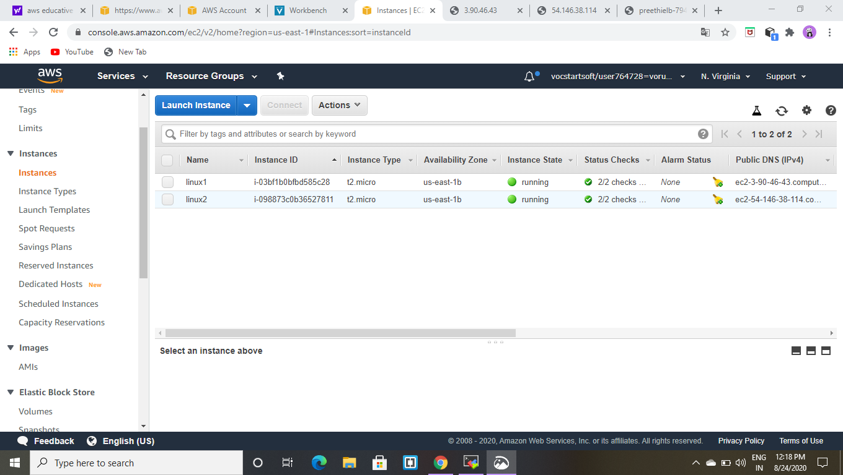

Open the linux 1 instance

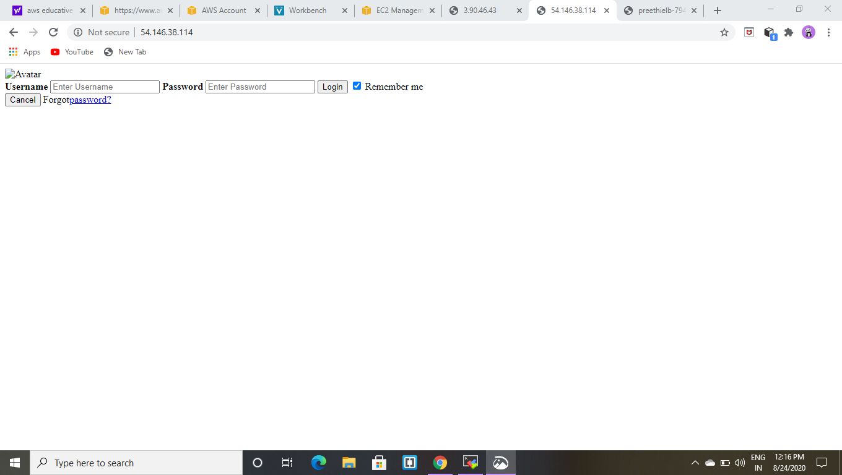

Open the linux 2 instance

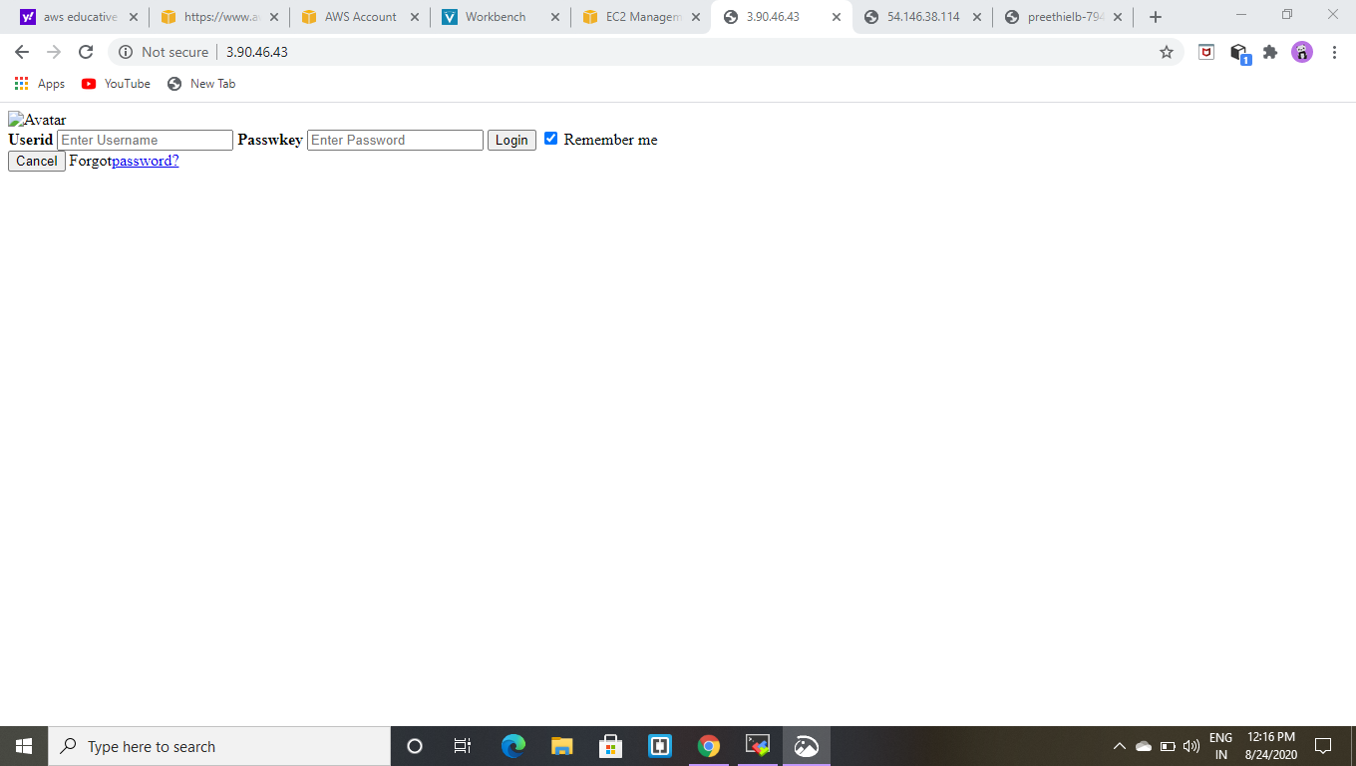

Opening the created load balancer.

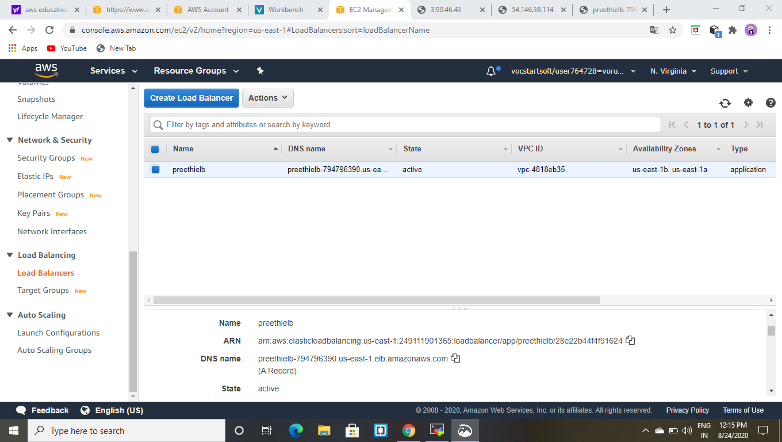

Now copy the DNS name and search in google.

